Projectile Motion Analyser

Made by physicist, for physicists

EVERYTHING YOU ASKED FOR

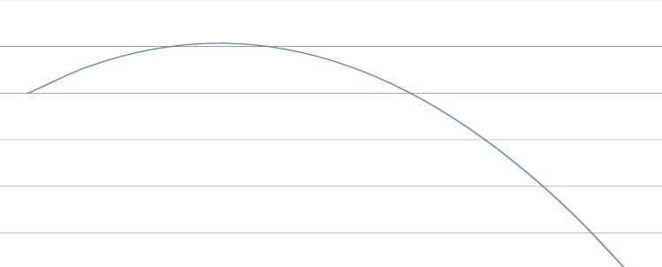Projectile Motion Analyser can answer every single projectile motion question. From the questions in Surfing Space to questions straight from the HSC papers, Projectile Motion Analyser will give you all the answers you need.\*

A GRAPH FOR ALL YOUR PROJECTILES

Projectile Motion Analyser features a graph of your projectile’s motion, which displays exactly where your projectile travels. Even if your projectile starts or ends at a height above the ground, the graph will display it.

ALL IN SI UNITS, LIKE NORMAL PHYSICS

Projectile Motion Analyser will accept all variables in SI units (not like Maths). No km/h, all velocities are in m/s, like normal.

EASY TO USE

Projectile Motion Analyser has been certified as easy to use, and so physicists will find it very easy to use, and can solve their projectile motion problems in seconds.

DOWNLOAD TODAY

SOLVE YOUR PROBLEMS

\* To projectile motion problems